To: Vinny Saccenti

Re: Create New Users

From: Team3

Hello Mr. Saccenti,

We have added in these new users as per your request. The user “Michael” was given administrative permissions and all three users were added to the group “Corleone”. Below is screenshots of the users after being added.

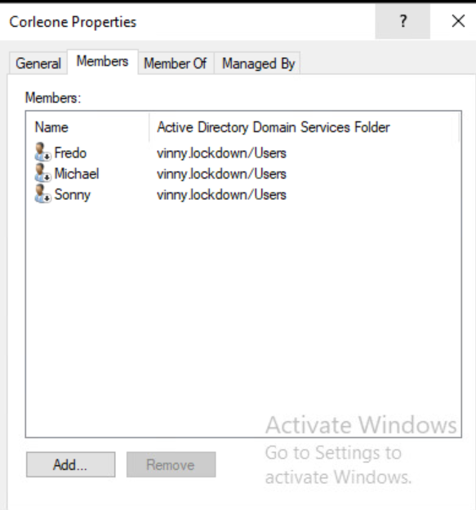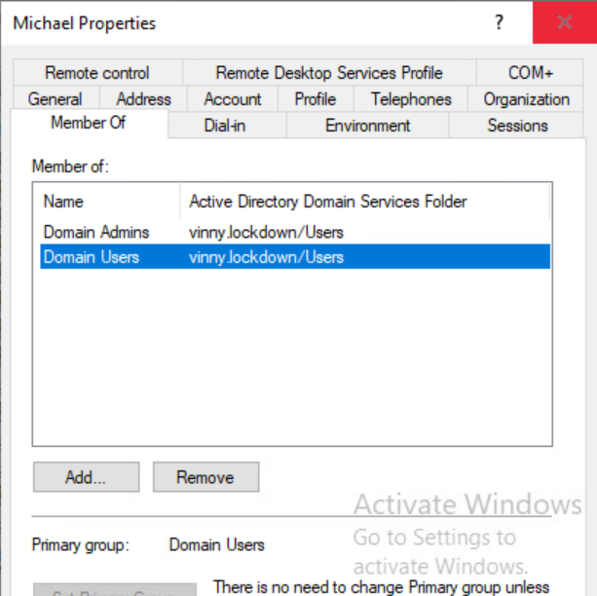

Best,

Team3